Task #01 Create VPC Infrastructure
Table of Contents
Description: 1
Solution 1
Architecture Diagram 1
1.1 Create a custom VPC with a specified CIDR block 2
1.2 Define public and private subnets across multiple Availability Zones 3
1.3 Set up an Internet Gateway and attach it to the VPC 3
1.4 Create route tables and associate them with appropriate subnets 4
1.5 Configure NAT Gateway in a public subnet for private subnet internet access 5
1.6 Launch EC2 instances in private and public subnets as needed 6
1.7 Implement security groups and network ACLs for traffic control 6
1.8 Enable VPC Flow Logs for network traffic monitoring 7
1.9 Create VPC Endpoints for secure private connectivity to AWS services 8
1.10 Use Elastic IPs for NAT Gateway or public-facing resources 8
1.11 Test connectivity between subnets and to the internet 9

Description:
Custom Virtual Private Cloud (VPC) setup to host secure and scalable AWS resources across public and private subnets with proper routing, NAT, and security configurations.

Solution

Architecture Diagram

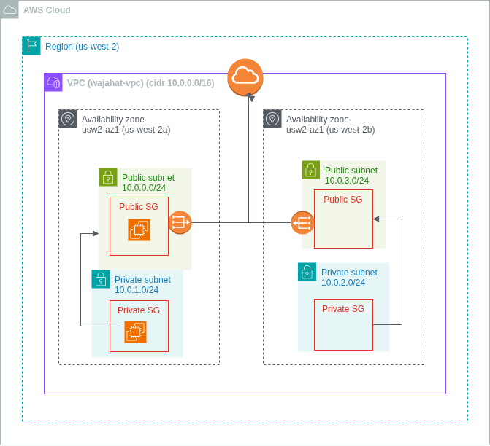

1.1 Create a custom VPC with a specified CIDR block
STEPS
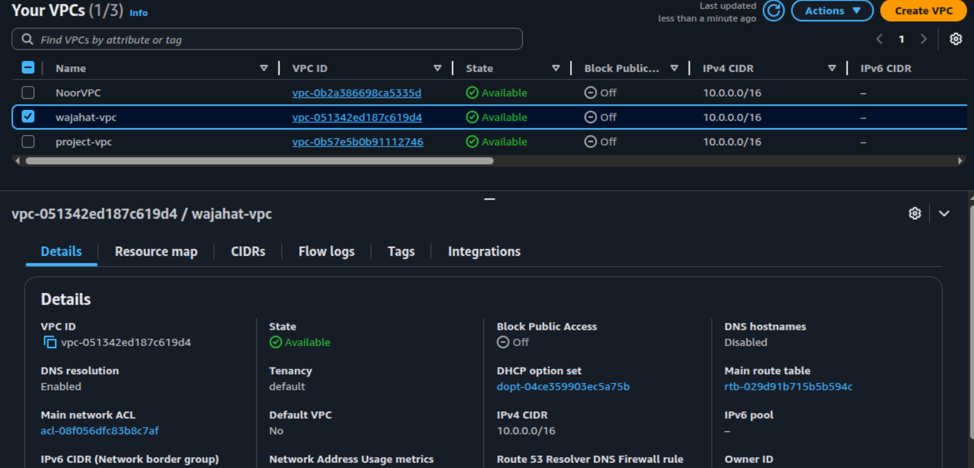
- Create a VPC with CIDR block (10.0.0.0/16) which will host all our AWS resources.

1.2 Define public and private subnets across multiple Availability Zones
STEPS
- From the console, create a public and private subnet inside 2 Availability Zones (AZ) (us-west-2a and us-west-2b).
- The public subnets were assigned 10.0.0.0/24 and 10.0.2.0/24, while the private subnets were 10.0.1.0/24 and 10.0.3.0/24.
- This separation ensures that resources like web servers can stay publicly accessible, while databases or internal services remain isolated inside private subnets.
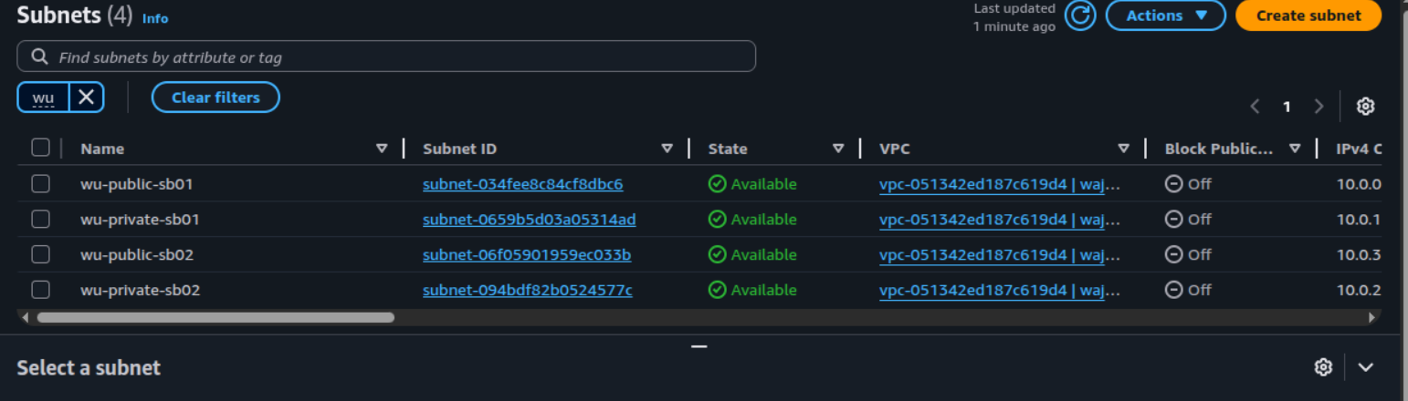

1.3 Set up an Internet Gateway and attach it to the VPC

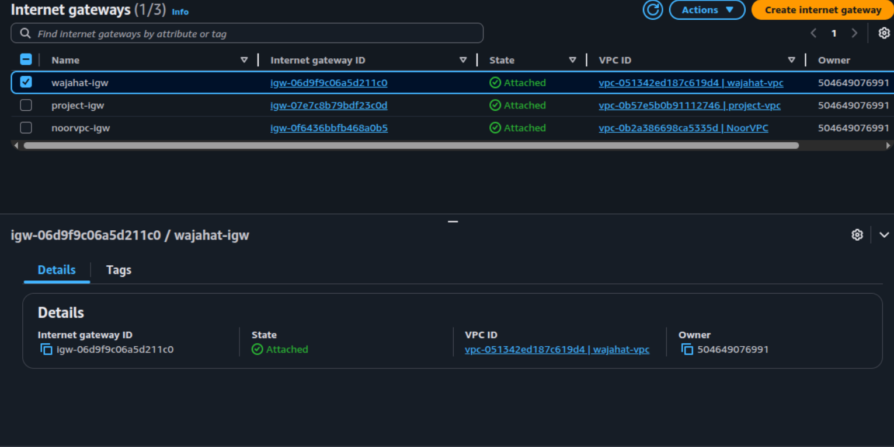
- This component is required to route traffic between the internet and instances inside the public subnets. Without an IGW, public-facing resources cannot be reached from the outside world.
- Also, the machines from the private subnet will send the outboun traffic using public subnet’s IGW.

1.4 Create route tables and associate them with appropriate subnets

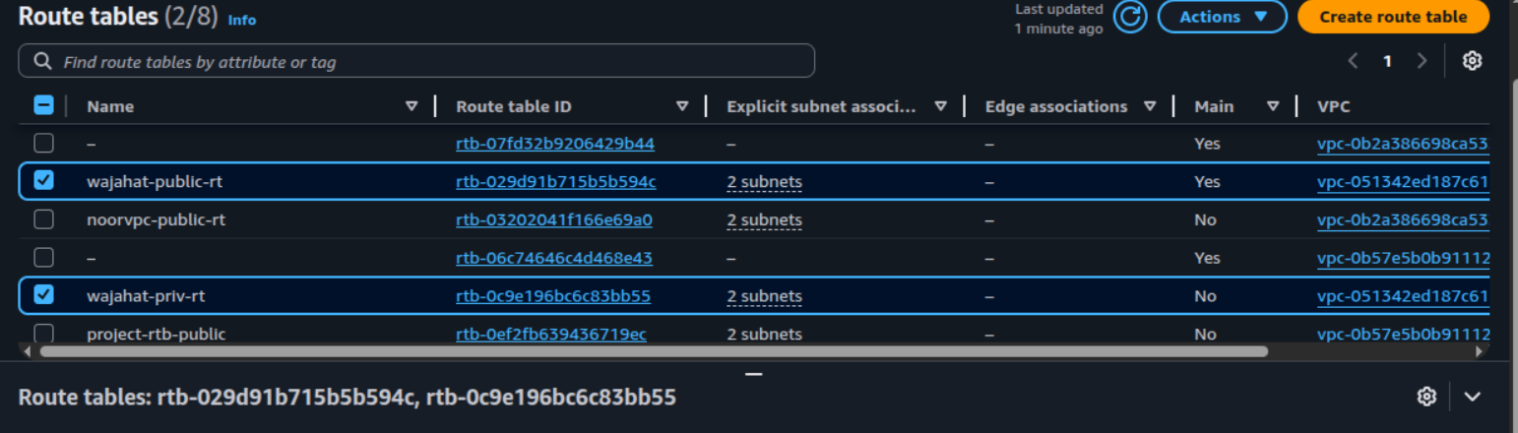
- Route tables are created separately for public and private subnets.
- The public route table was linked to both public subnets and configured with a default route 0.0.0.0/0 pointing to the IGW for direct internet access.
- The private route table was linked to the local (for internal VPC communication) and the NAT GW for outbound communication.
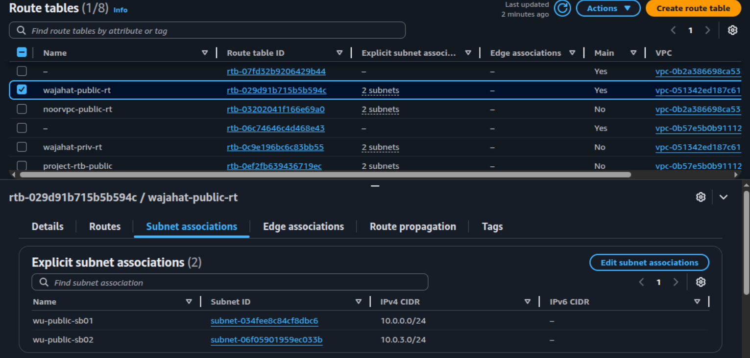

1.5 Configure NAT Gateway in a public subnet for private subnet internet access

- I created a NAT Gateway in the public subnet (10.0.0.0/24) and attached an Elastic IP to it, so that even if the instance reboots, the incoming data packets are not lost and communication stays up.
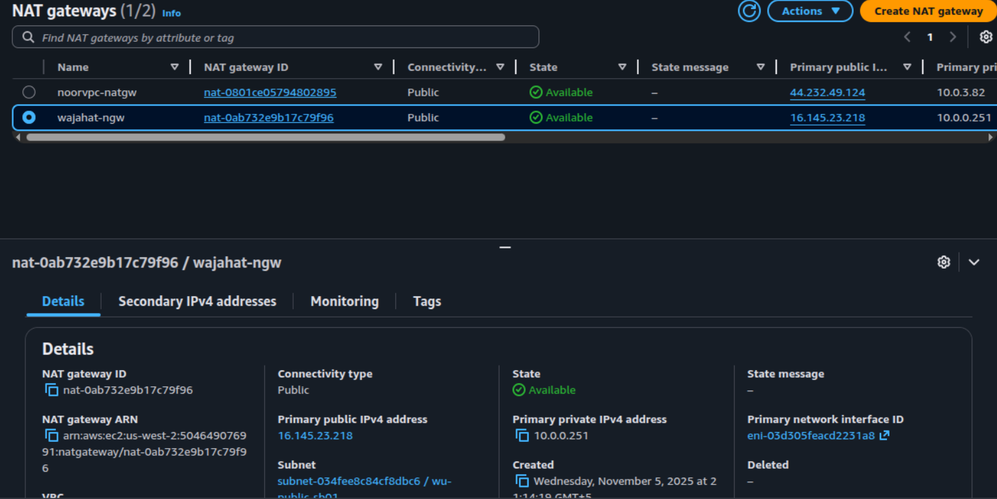
- The NAT Gateway sends outbound traffic from private instances through the public subnet and the IGW, while still keeping those instances unreachable from the internet.

1.6 Launch EC2 instances in private and public subnets as needed
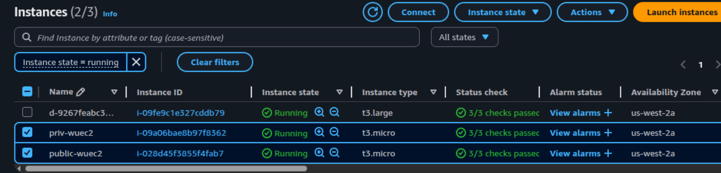
- I created 2 ec2 instances, one for public and one internal private.
- The public ec2 acts as a Bastion host and the private one acts as an internal server sending outbound traffic to public server.

1.7 Implement security groups and network ACLs for traffic control
- I created two SG, one for public and one for private resources.
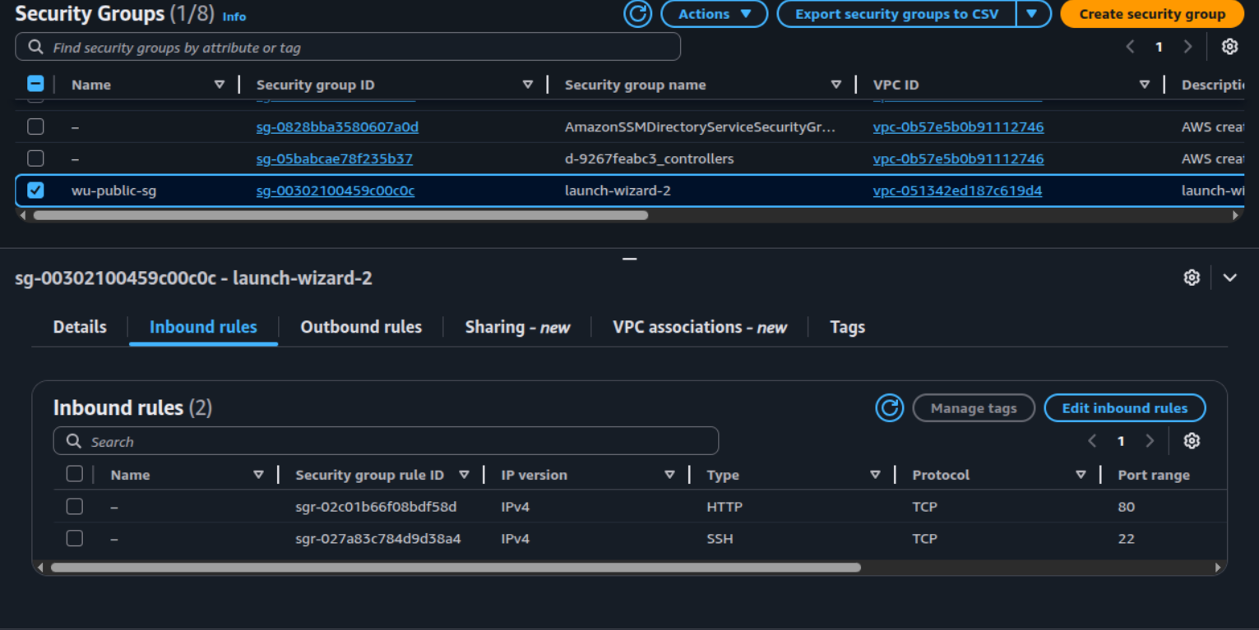
- The public sg has inbound traffic configured to allow ssh on port 22 and http on port 80
- The private SG only allowed SSH from the public SG.

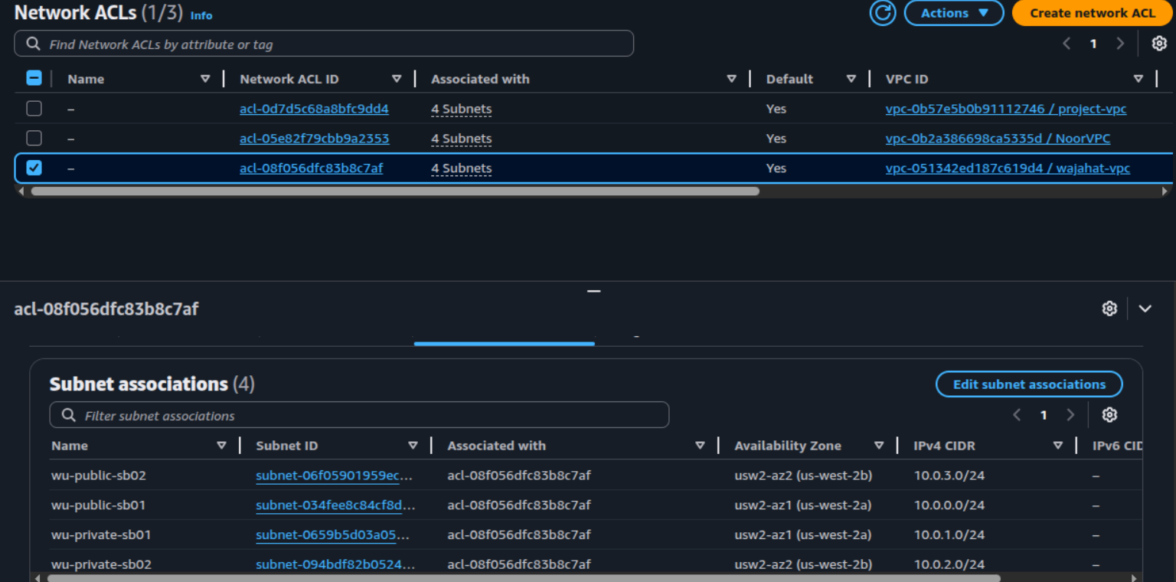
- Default NACLs were kept as they already allowed appropriate inbound and outbound traffic for this setup.

1.8 Enable VPC Flow Logs for network traffic monitoring
- To monitor network activity and troubleshoot traffic patterns, I enabled VPC Flow Logs and directed them to a CloudWatch Log Group.
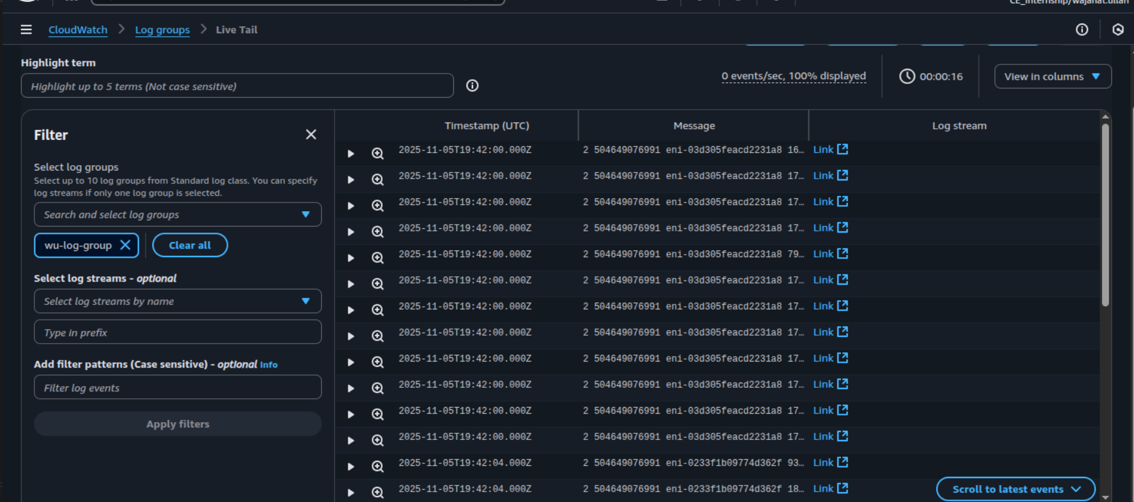
- I created a separate iam role and a policy for the logs to sent and reveived by cloudwatch log group.

1.9 Create VPC Endpoints for secure private connectivity to AWS services
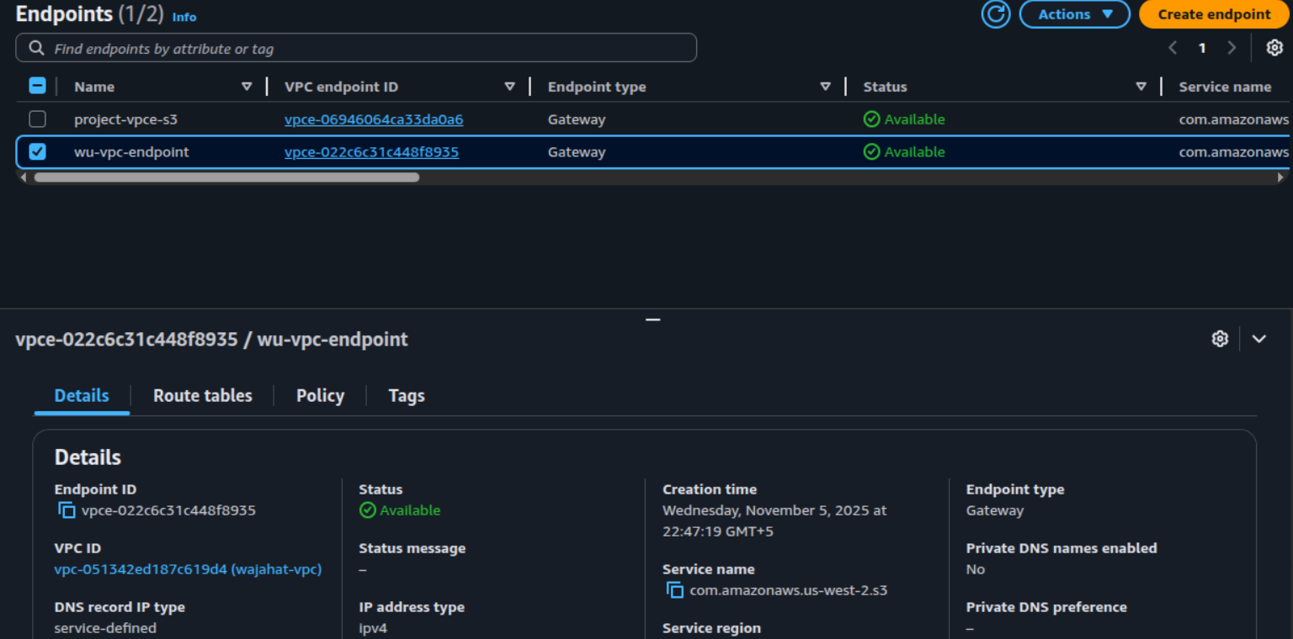
- I created a VPC endpoint for the aws S3 service and associated with private rt.
- This ensures that instances in private subnets can connect to S3 securely, without routing traffic through the NAT Gateway or the public internet.

1.10 Use Elastic IPs for NAT Gateway or public-facing resources
- An elastic IP was already attached to the NAT GW.
- This ensures stable connectivity for all outbound requests from private resources that rely on the NAT for internet access.

1.11 Test connectivity between subnets and to the internet
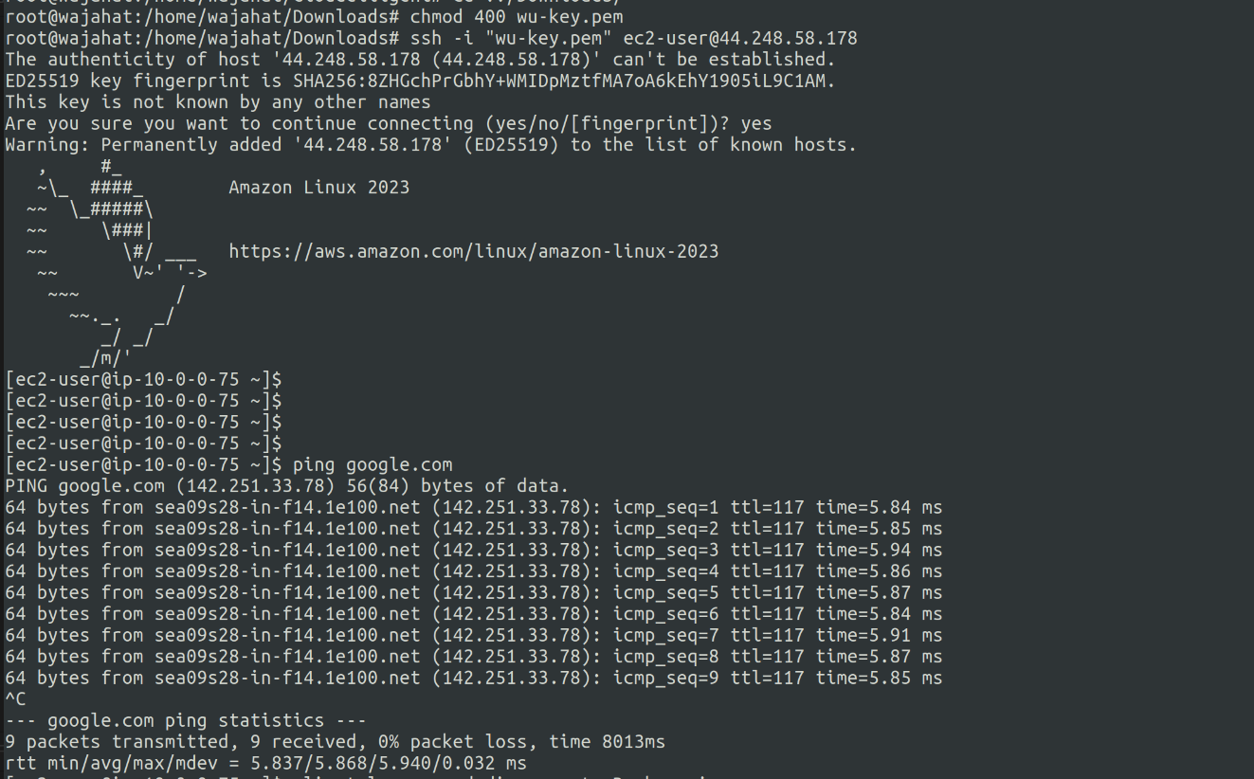
- Here, I changed the permissions on the pem file, connected to the public server.
- As shown, I was able to send outbound traffic (ping and curl)
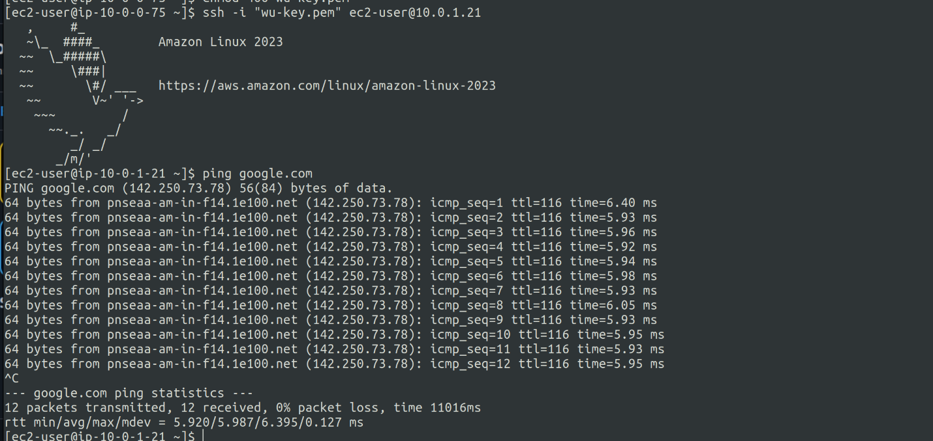
- From the public ec2, I connected to the private instance.
- As shown, private instance can send outbound traffic utilizing the NAT GW.

